Ideation Phase
Define the Problem Statements

Date | 02 November 2026
Team ID: | Individual Project
Project Name | StaffSync
Maximum Marks | 2 Marks

Customer Problem Statement Template:
To define the core problems faced by HR teams, Managers and Employees while handling routine human resource activities, and use these insights to guide the development of StaffSync.
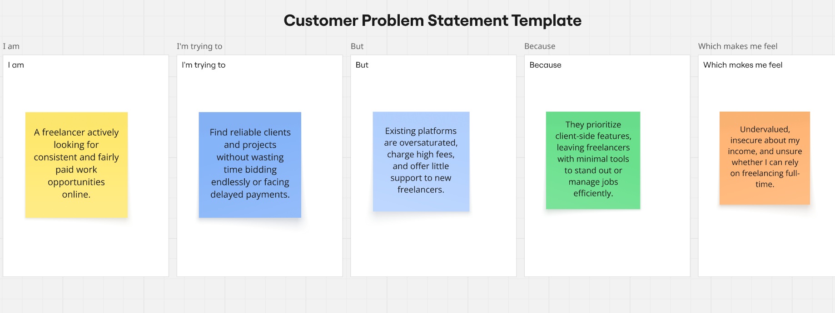
Reference: https://miro.com/templates/customer-problem-statement/

Problem Statement (PS) | I am (Customer) | I’m trying to | But | Because | Which makes me feel
PS-1 | an HR administrator. | maintain employee records and manage attendance and leave activities in one place. | information and requests can be scattered across different records or processes. | there is no single role-based platform to manage and track these routine HR tasks. | overloaded and concerned about delays or missing information.
PS-2 | an employee. | check my attendance, apply for leave, view assigned training and receive workplace updates. | I may not have a simple place to access all these HR services and relevant information. | the processes may be handled separately and access to information may not be clearly organised. | inconvenienced and less informed about my work-related activities.

